Playwright Test Agents:
Planner
Generator
Healer

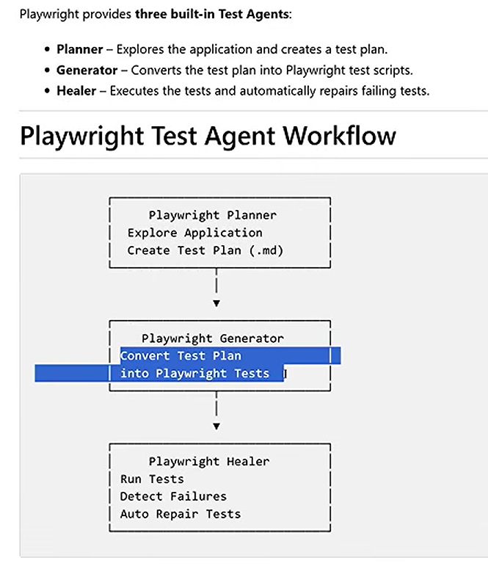
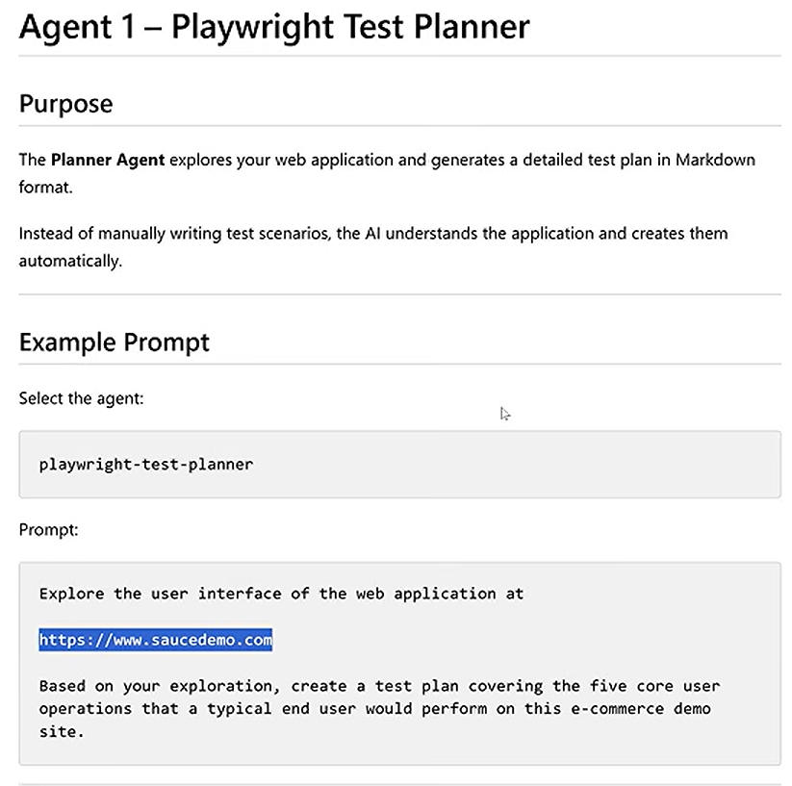
Agent 1 - Playwright Test Planner
Purpose
The Planner Agent explores your web application and generates a detailed test plan in Markdown format.
Instead of manually writing test scenarios, the Al understands the application and creates them automatically.
Example Prompt
Select the agent:
playwright-test-planner
Prompt:
Example Prompt: Explore the user interface of the web application at https://www.saucedemo.com
Based on your exploration, Create a test plan covering the five core user operations that a typical end user will perform on this e-commerce demo site.

playwright-test-generator
Prompt 1: To generate tests for all the scenarios from the test plan:
Generate Playwright tests for all the scenarios provided in the test plan.
Prompt 2: To generate test for the specific scenario from the test plan:
Create a Playwright test for scenario 1.1 from test-plan.md using the Playwright test generator agent.
nterface of the web application at
https://www.saucedemo.com
Based on your exploration, create a test plan covering the five core user operations that a typical end user would perform on this e-commerce demo site.

2.Test generator:
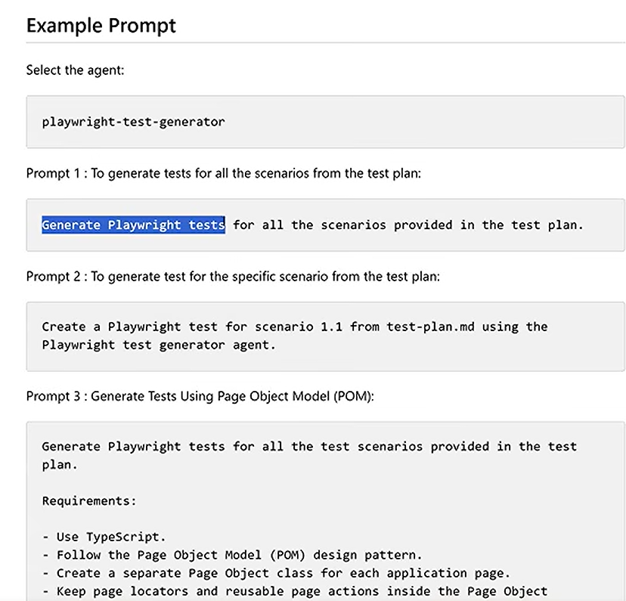
Example Prompt
Select the agent:
playwright-test-generator
Prompt 1: To generate tests for all the scenarios from the test plan:
Generate Playwright tests for all the scenarios provided in the test plan.
Prompt 2: To generate test for the specific scenario from the test plan:
Create a Playwright test for scenario 1.1 from test-plan.md using the Playwright test generator agent.

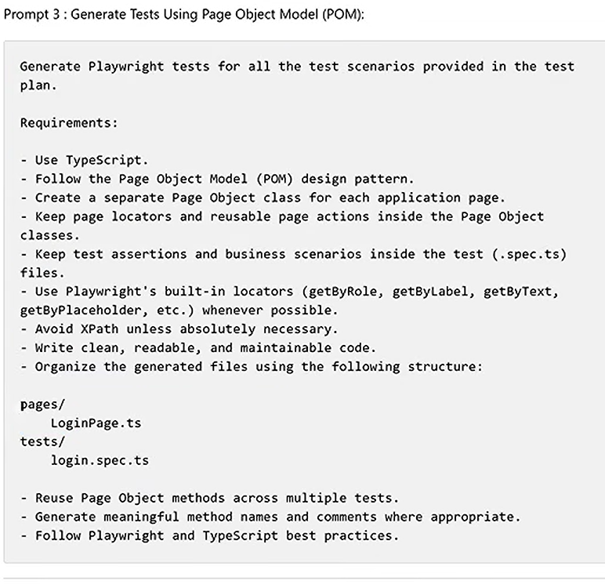
Prompt 3: Generate Tests Using Page Object Model (POM):
Generate Playwright tests for all the test scenarios provided in the test
plan.
Requirements:
- Use TypeScript.
- Follow the Page Object Model (POM) design pattern.
- Create a separate Page Object class for each application page.
- Keep page locators and reusable page actions inside the Page Object classes.
- Keep test assertions and business scenarios inside the test (.spec.ts) files.
- Use Playwright's built-in locators (getByRole, getByLabel, getByText, getByPlaceholder, etc.) whenever possible.
- Avoid XPath unless absolutely necessary.
- write clean, readable, and maintainable code.
- Organize the generated files using the following structure:
pages/
LoginPage.ts
tests/
login.spec.ts
- Reuse Page Object methods across multiple tests.
- Generate meaningful method names and comments where appropriate.
- Follow Playwright and TypeScript best practices.

3. Healer agent
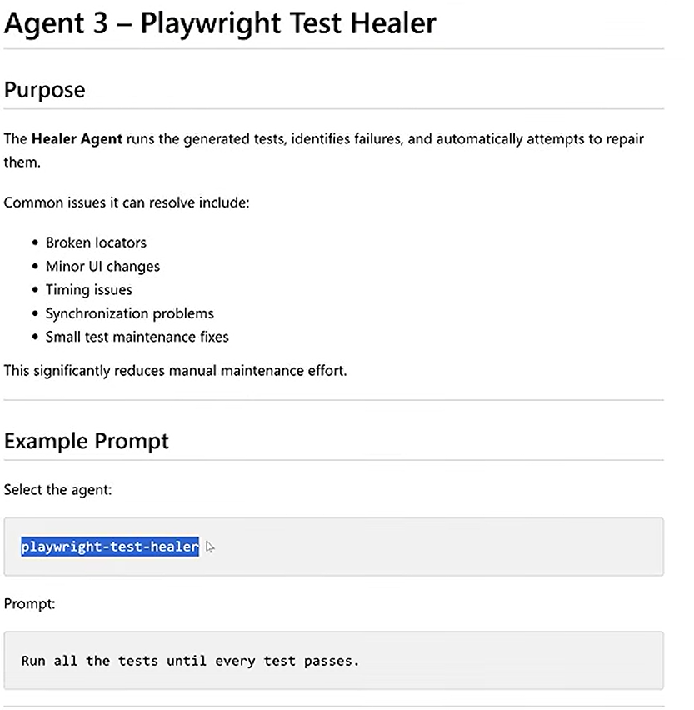
Agent 3 - Playwright Test Healer
Purpose
The Healer Agent runs the generated tests, identifies failures, and automatically attempts to repair them.
Common issues it can resolve include:
• Broken locators
Minor Ul changes Timing issues
Synchronization problems
• Small test maintenance fixes
This significantly reduces manual maintenance effort.
Example Prompt
Select the agent:
playwright-test-healer ▷
Prompt:
Run all the tests until every test passes.

